24.44: a)
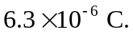
b)
c) The addition of the mylar doesn’t affect the electric field since the induced charge cancels the additional charge drawn to the plates.

